TASK 01

#include <iostream>

using namespace std;

int main()

{

int x;

do{

cout<<"enter a number :";

cin>>x;

}

while(x>0);

return 0;

}

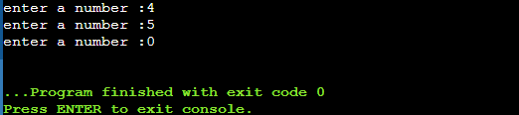

TASK 02

#include <iostream>

#include<math.h>

using namespace std;

int main() {

int x, y , result=0 ,i;

char operation;

do {

cout<<"enter first number"<<endl;

cin>>x;

cout<<"enter second number"<<endl;

cin>>y;

cout<<"enter operation(+for addition,- for subtaction, \* for multiplication, / for division"<<endl;

cin>>operation;

switch (operation) {

case '+':

result=x+y;

break;

case '-':

result=x-y;

break;

case '\*':

result=x\*y;

break;

case '/':

result=x/y;

break;

}

cout<<"= "<<result <<endl;

cout<<"press 1 to continue and 0 for termination"<<endl;

cin>>i;

}

while (i==1);

return 0;

}

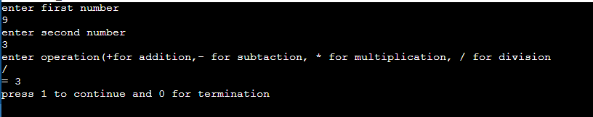

TASK 03 (a)

#include <iostream>

using namespace std;

int main() {

int sumEven = 0;

int num = 2;

while (num <= 100) {

sumEven += num;

num += 2;

}

cout << "The sum of even numbers between 2 and 100 is: " << sumEven << std::endl;

return 0;

}

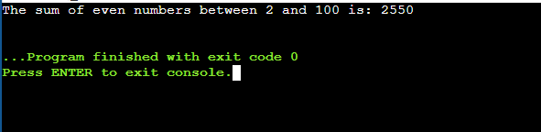

(b)

#include <iostream>

using namespace std;

int main() {

int sum = 0;

int i = 1;

do {

sum += i\*i;

i++;

} while (i <= 100);

cout << "The sum of squares between 1 and 100 is: " << sum << endl;

return 0;

}

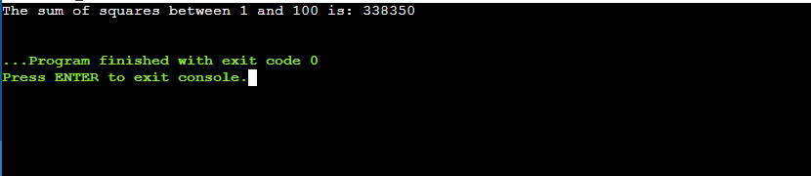

TASK 04 (a)

#include <iostream>

#include <cmath>

using namespace std;

int main() {

int exponent = 0;

long long result;

do {

result = pow(2, exponent);

cout << "2^" << exponent << " = " << result << endl;

exponent++;

} while (exponent <= 20);

return 0;

}

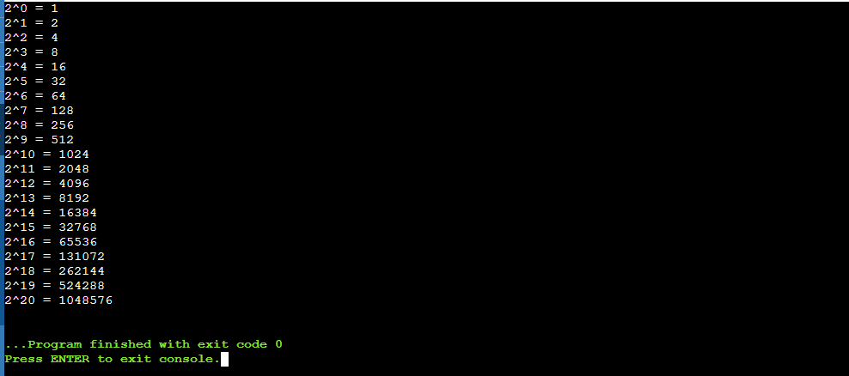

// (b)

#include <iostream>

using namespace std;

int main() {

int int1, int2;

int sum;

cout<<"Enter first integrer: ";

cin>>int1;

cout<<"Enter the last integer: ";

cin>>int2;

if(int1%2 == 0){

int1++;

}

for(int i=int1; i<=int2; i+=2){

sum+=i;

}

cout<<"Sum of odd numbers between "<<int1<<" and "<<int2<<" is: "<<sum<<endl;

return 0;

}

